Walkthrough: User Authentication & Route Protection
This walkthrough documents the implementation of the user login screen, credentials authentication (integrated with Convex), Next.js route protection middleware, and visual verification.

1. Authentication Engine
We created a lightweight, environment-agnostic JWT/session utility using the native **Web Crypto API**:
- **`src/services/auth.ts`**: Provides `signJWT` and `verifyJWT` methods using HMAC-SHA256 signature verification. Compatible with both standard Node.js (API routes) and Edge (Middleware) runtimes.

2. Database Schema & Seeding
To support manual credential testing:
- **`convex/schema.ts`**: Added `password: v.optional(v.string())` to the `users` schema.
- **`convex/seed.ts`**: Updated the seed mutation to populate `password: 'MockPassword123!'` for the default admin user.
- **`src/db/schema.ts` & `src/db/helpers.ts`**: Mirror changes applied to the Drizzle PostgreSQL schema and seed helpers.

3. Backend API Routes
Created authentication endpoints:
- **`/api/auth/login`**: Receives credentials, verifies them against Convex (or PostgreSQL fallback), signs a JWT token, and writes it to a secure `HttpOnly` cookie.
- **`/api/auth/logout`**: Clears the session cookie by setting its expiration to the past.

4. Route Protection Middleware
- **`src/middleware.ts`**: Next.js middleware that intercepts all requests to `/dashboard/:path*` and `/login`.
- Unauthenticated visits to `/dashboard` are redirected to `/login`.
- Authenticated visits to `/login` are redirected to `/dashboard`.
- Injects verified context headers (`x-tenant-id`, `x-user-email`) downstream.

5. Frontend & Layout integration
- **`src/app/login/page.tsx`**: High-end dark mode login interface utilizing glassmorphism, Outfit typography, Lucide icons, loading states, and credential error notices.
- **`src/app/dashboard/layout.tsx`**: Restructured the layout with client-side state handling to place a Sign Out action button in the desktop sidebar and mobile header.
---

6. Visual Verification Flow

Route Protection Redirect
Trying to visit `/dashboard` directly redirects the user back to the login screen:
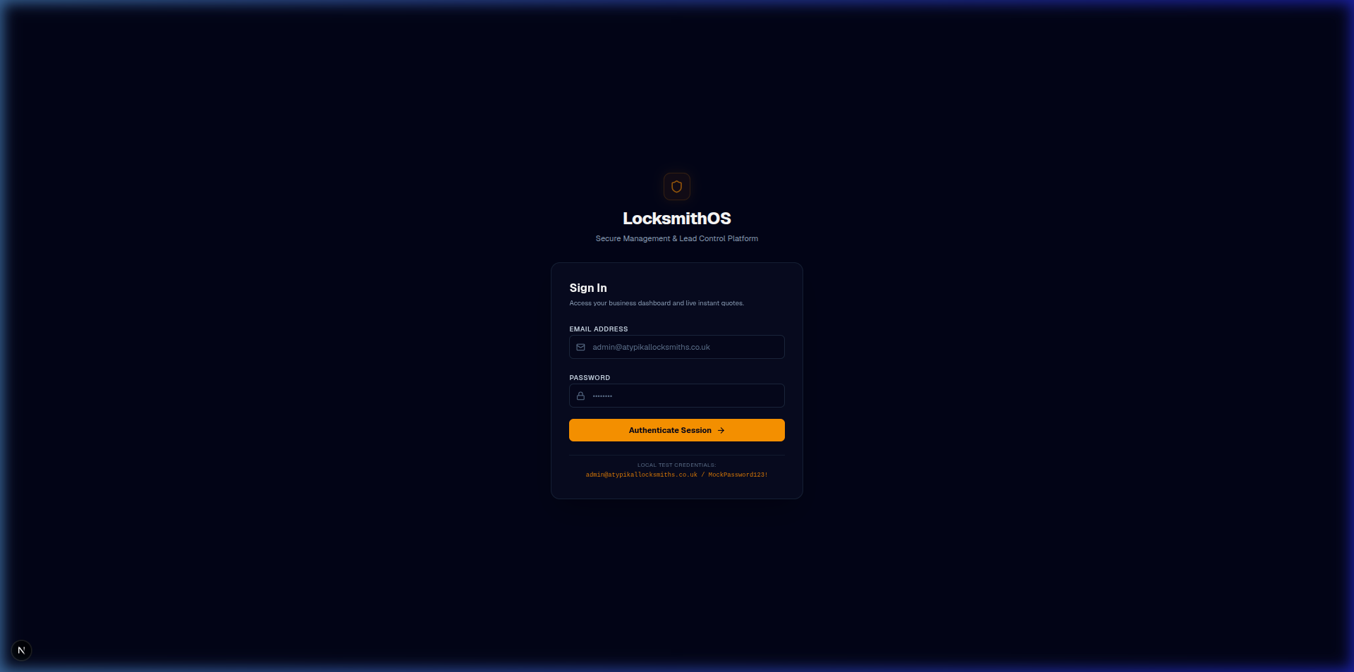
Figure: Route Protection Redirect

Invalid Credentials Error
If incorrect credentials are submitted, a clean error banner appears:
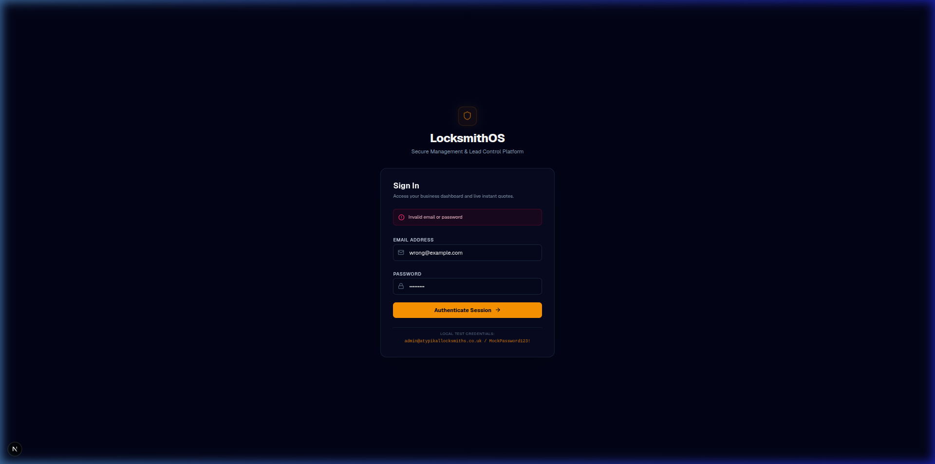
Figure: Authentication Error

Successful Sign-In
Submitting correct credentials (`admin@atypikallocksmiths.co.uk` / `MockPassword123!`) redirects the user to the protected dashboard:
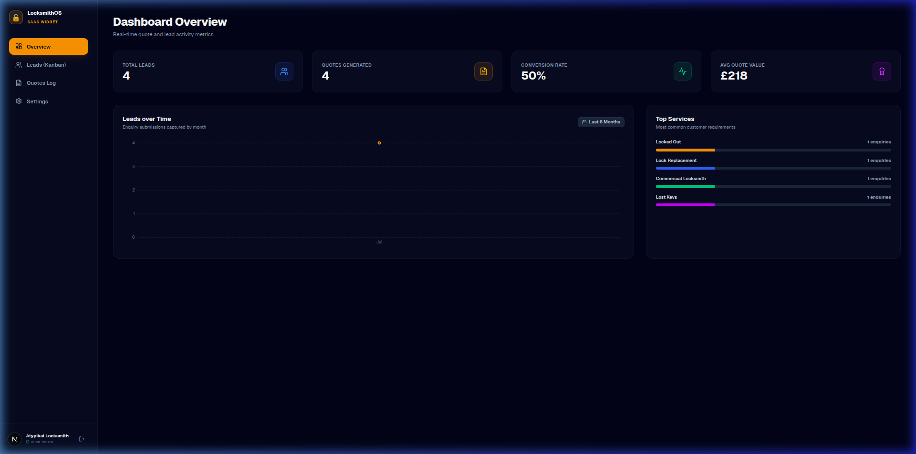
Figure: Seeded Dashboard

Successful Log Out
Clicking the Sign Out button clears cookies and immediately takes the user back to the login page:
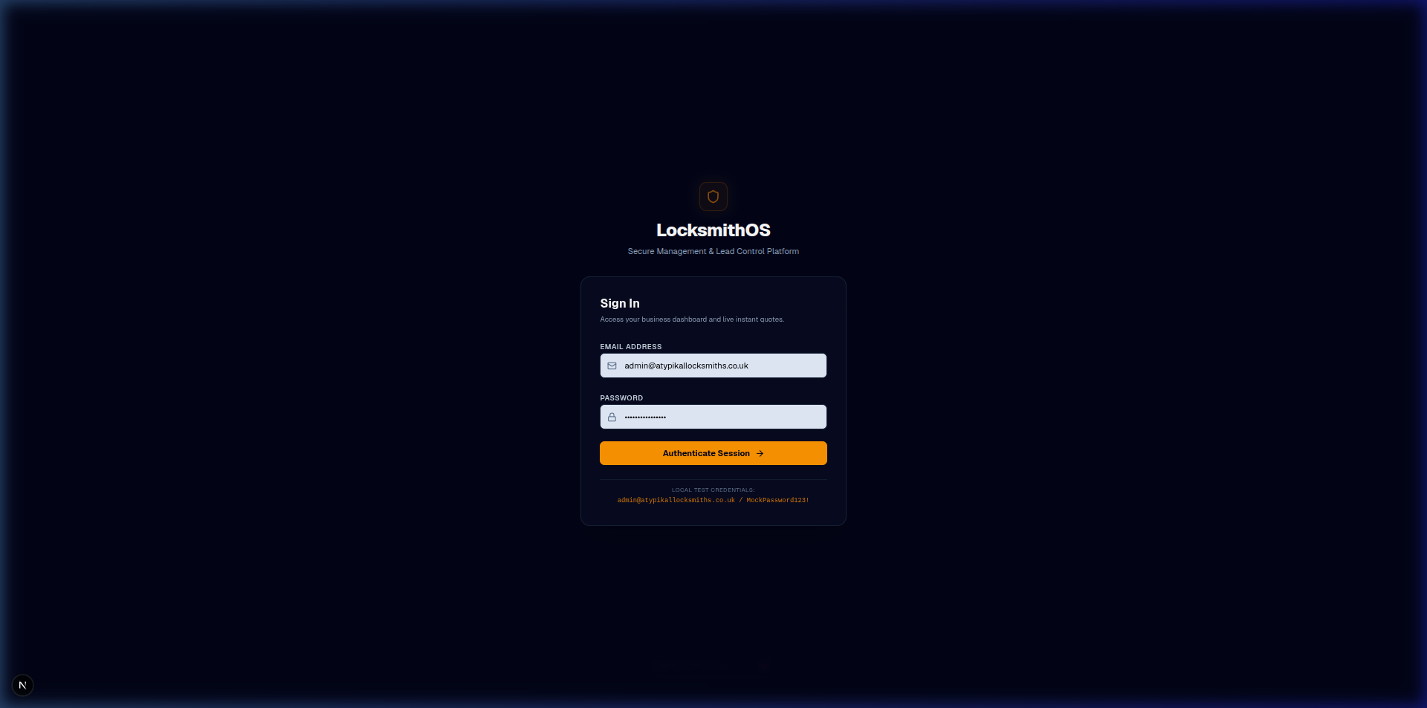
Figure: Logged Out Screen

